**12. Forms - Use of HTML tags in forms like select, input, file, textarea, etc.**

<!DOCTYPE html>

<html>

<head>

<title>Form Elements</title>

</head>

<body>

<center><h1>Form Elements</h1></center>

<form>

<label for="t1">Text Box:</label>

<input type="text" id="t1" name="name" value=""><br><br>

Radio Buttons:<br>

<input type="radio" id="r1" name="gender" value="male">Male<br>

<input type="radio" id="r2" name="gender" value="female">Female<br><br>

Check Box:

<input type="checkbox" id="c1" name="subscription" value="subscribe"><br><br>

File:

<input type="file" id="e1" name="file"><br><br>

Select:<br>

<label for="sem">Semester:</label>

<select name="sem" id="sem">

<option value="1">1 Sem</option>

<option value="2">2 Sem</option>

</select><br><br>

Text Area:<br>

<textarea id="ta1" name="textarea" rows="4" cols="50">

</textarea><br><br>

<fieldset>

<legend>Personal Details:</legend>

<label for="fname">First name:</label>

<input type="text" id="fname" name="fname"><br><br>

<label for="lname">Last name:</label>

<input type="text" id="lname" name="lname"><br><br>

</fieldset><br><br>

<input type="button" id="submitBtn" name="submit" value="Submit"><br>

</form>

</body>

</html>

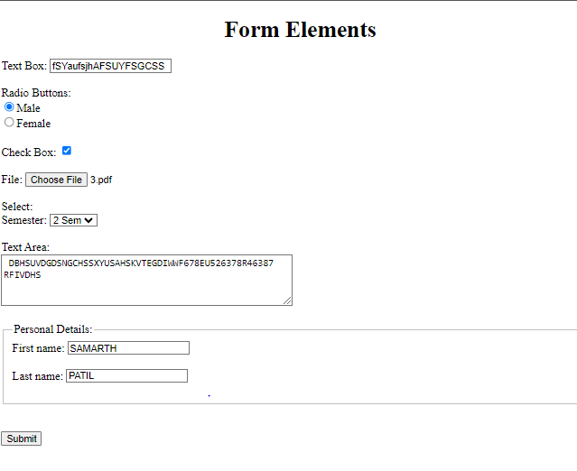**OUTPUT:**

**13.Testing single page application (Registration form) using React.**

**Creating React.js app**

**Step1**:-Install the npm using Command :**“npm insatall”**

**Step2**:-Create app using below command :**“npx create-react-app projectName”**

**Step3**:- After completed the installation go to the directory :**"cd projectName”**

**Step4:-** Create Hello.js file in src folder

**E:\reactapp\project\src\Hello.js**

import { useState } from 'react';

import './App.css';

export default function Form()

{

// States for registration

const [name, setName] = useState('');

const [email, setEmail] = useState('');

const [password, setPassword] = useState('');

const [submitted, setSubmitted] = useState(false);

const handleName = (e) => {

setName(e.target.value);

};

const handleEmail = (e) => {

setEmail(e.target.value);

};

const handlePassword = (e) => {

setPassword(e.target.value);

};

const handleSubmit = (e) => {

e.preventDefault();

if (name === '' || email === '' || password === '') {

alert("Please enter all the fields");

} else {

setSubmitted(true);

}

};

// Showing success message

const successMessage = () => {

if(submitted)

return (

<div className="success" >

<h1>User {name} successfully {email} registered!!</h1>

</div>

);

};

return (

<div className="form">

<div>

<h1> Login to ISRP </h1>

</div>

{/* Calling to the methods */}

<div className="messages">

{successMessage()}

</div>

<form>

<fieldset>

{/* Labels and inputs for form data */}

<label className="label">Name</label>

<input onChange={handleName} className="input" value={name} type="text" /><br></br>

<label className="label">Email</label>

<input onChange={handleEmail} className="input" value={email} type="email" /><br></br>

<label className="label">Password</label>

<input onChange={handlePassword} className="input" value={password} type="password" /><br></br>

<button onClick={handleSubmit} className="btn" type="submit">

Submit

</button>

</fieldset>

</form>

</div>

);}

**E:\reactapp\project\src\App.css**

.input {

width: 30%;

padding: 12px 20px;

margin: 8px 0;

display: inline-block;

border: 1px solid #ccc;

border-radius: 4px;

box-sizing: border-box;

}

**E:\reactapp\project\src\index.js**

import React from 'react';

import ReactDOM from 'react-dom';

import Form from './Hello'; // Import the Form component from Hello.js

ReactDOM.render(

<React.StrictMode>

<Form /> {/* Render the Form component */}

</React.StrictMode>,

document.getElementById('root')

);

**OUTPUT:**

